CAS PY 106

In-Class Note 20

1. What is a wave?
2. “wave is a disturbance that carries energy from one place to another”
3. Wave carries energy to the right
4. 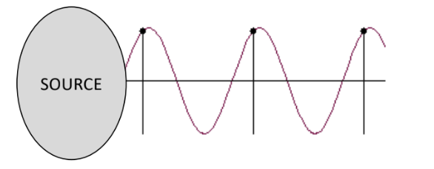
5. Transverse Waves
6. Wave moves through a medium (water, air, etc.)
7. In transverse waves, “particles” move perpendicular to the wave direction
8. Wave moves to the right & points on string move up/down
9. Longitudinal waves
10. In longitudinal waves, “particles” move parallel to the wave direction
11. For example: sound waves (pressure waves)
12. Wave moves to the right & atoms in gas move left/right
13. 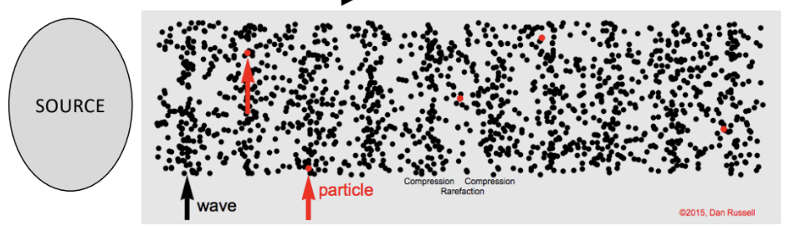
14. How can we describe a wave?
15. The wave is changing in time and in space. How can we describe this complex motion?
16. The wave equation: y(x,t) = A\*sin(w\*t +- k\*x)
17. A sine function of time t going up and down in time
18. Also a sine function of space x left and right through space
19. Amplitude A of the wave
20. A = amplitude
21. Maximum y that a point on the string can reach
22. 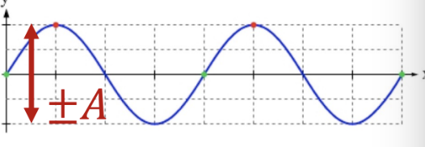
23. Wavelength lambda and wavelength k
24. The “size” of the wave is indicated by the wavelength lambda
25. But you can also use the wavenumber k
26. K = wavenumber

K = 2pi/lambda [rad/m]

X: 0 🡪 lambda

K\*X: 0 🡪 2pi

1. 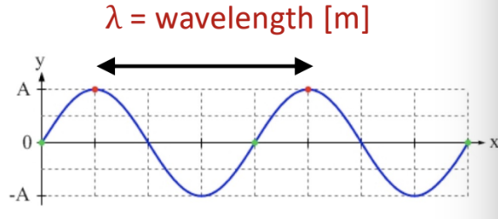
2. Frequency f of the wave
3. How fast a point at x moves up and ddown is indicated by the frequency f or the angular frequency w or the period T
4. 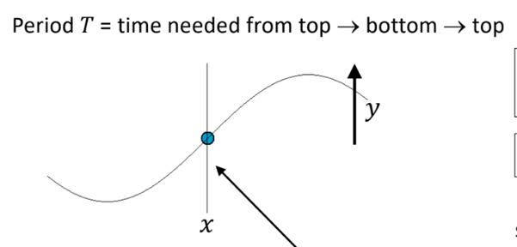
5. f = 1/T (Hertz or Hz)
6. w = 2pi\*f (rad/s)

OR

w = 2pi/T

1. Direction of the wave
2. Sign between terms tells you the direction
3. + for going left (-x direction)
4. – for going right (+x direction)
5. Wavelength and period
6. 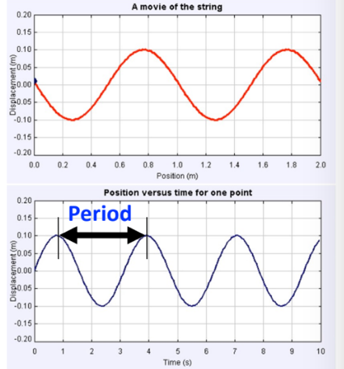
7. The top graph is the motion of the wave versus position 🡪 use to find wavelength
8. The graph underneath is plot of the displacement of a single point of the wave as a function of time 🡪 use to find period
9. Maximum speed of a point moving up and down
10. Vmax= A \* w = A \* 2pi \* f = A \* 2pi / T
11. Note that the maximum speed of a single point occurs when point crosses y = 0
12. Also, this speed is speed is quite a different thing from the speed of the wave (which travels in the x-direction)
13. So, transverse motion of a single point on the string travels perpendicular to wave propagation
14. Speed of the wave moving in the x-direction
15. V = lambda / T or V = f \* lambda

OR

V = (FT / (kg/m))^0.5 🡪 the wave speed if medium is a string with mass/unit length of u (kg/m), if its shaken to form a transverse wave